Aboriginal Name: nuh-gwulth
Scientific Name: Gaultheria Shallon
Common Names: salal, shallon
Description: A leathery-leaved shrub in the heather family (Ericaceae), which has a tendancy to sprawl throughout garden beds. Evergreen, its thick, tough, egg-shaped leaves are shiny and dark green on the upper surface, and rough and lighter green on the lower. It is tolerant of both sunny and shady conditions. The dark blue berries and the young leaves are both edible.
Image:
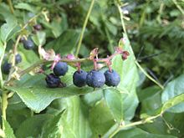

Aboriginal Name:
Scientific Name: Vaccinium angustifolium
Common Names: Native ‘Wild’ Blueberry, lowbush blueberry
Description: A low spreading deciduous shrub, usually 35 cm tall or less. The leaves are glossy blue-green in summer, turning purple in the fall. The leaf shape is broad to elliptical. Buds are brownish red in stem axils. The flowers are white, bell-shaped, 5 mm long. The fruit is a small sweet dark blue to black berry. This plant grows best in wooded or open areas with well-drained acidic soils.
Image:
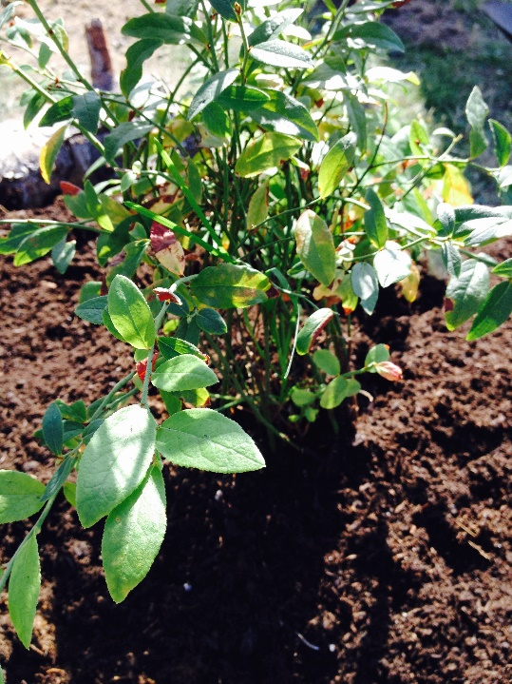
Aboriginal Name:
Scientific Name: Lychnis coronaria

Common Names: Rose Champion, dusty miller
Description: A clump-forming perennial with basal clumps of ovate, densely woolly, silver-gray leaves (to 5" long) and 5-petaled flowers (to 1" diameter).
Image:
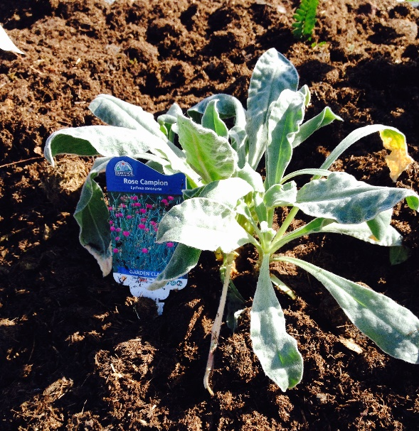

Aboriginal Name:
Scientific Name: Cornus canadensis
Common Names: Canadian bunchberry, quatre-temps, crackerberry, creeping dogwood
Description: A species of flowering plant in the Cornaceae (dogwood) family. It is a slow-growing herbaceous subshrub growing 10–20 cm tall, generally forming a carpet-like mat. The leafy green leaves are oppositely arranged on the stem, but are clustered with six leaves that often seem to be in a whorl. because the internodes are compressed. In the fall, the leaves have red tinted veins and turn completely red.
Image:
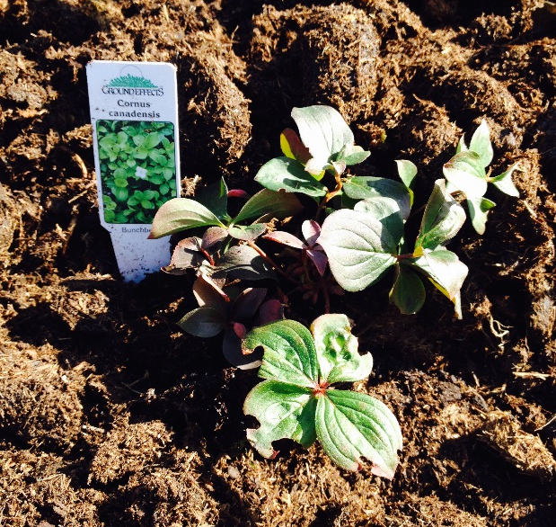

Aboriginal Name:
Scientific Name: Lupinus
Common Name: Lupine,
Description: A herbaceous perennial plant growing 0.3–1.5 m tall. Lupins have soft green to grey-green leaves which may be coated in silvery hairs, often densely so. The flowers are produced in dense or open whorls on an erect spike, each flower 1–2 cm long. The fruit is a pod containing several seeds.
Image:
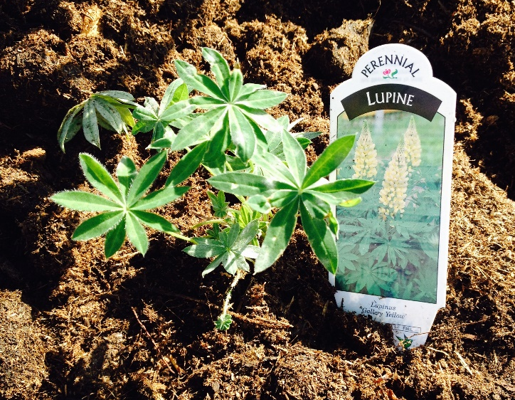

Aboriginal Name:
Scientific Name: Digitalis x mertonensis

Common Names: Strawberry Foxglove, Merton's Foxglove
Description: A perennial plant with bright green foliage that remains green year round. In late spring and early summer, abundant buds open to luscious blooms the color of crushed strawberries. They are so freely borne that the flowers crowd one another on the sturdy 3-foot stalk, overlapping for a very full, ultra-colorful look.
Image:
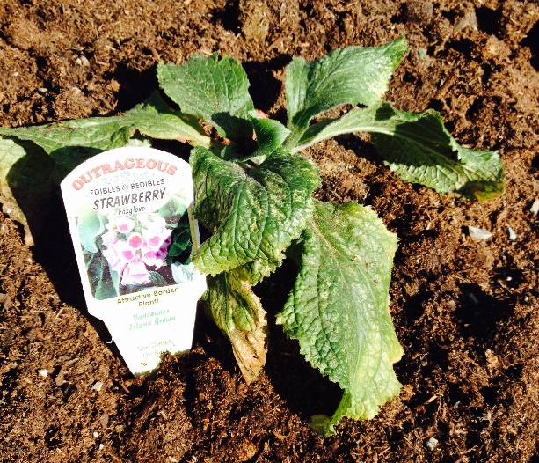

Aboriginal Name: tuhl-gwuh-dzoo-muhs
Scientific Name: Mahonia aquifolium
Common Name: Oregon grape
Description: A species of flowering plant in the family Berberidaceae, native to western North America. It is an evergreen shrub growing to 1 m (3 ft) tall by 1.5 m (5 ft) wide, with pinnate leaves consisting of spiny leaflets, and dense clusters of yellow flowers in early spring, followed by dark bluish-black berries.
Image:
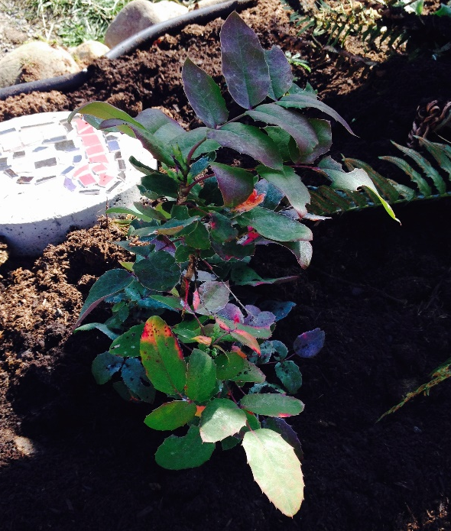
Aboriginal Name:
Scientific Name: Lonicera japonica 'Purpurea'
Common Name: Honeysuckle.
Description: This sprawling grower has vine-like stems displaying green leaves tinted purple underneath. Fragrant purplish-red flowers with white insides are attractive to hummingbirds
Image:
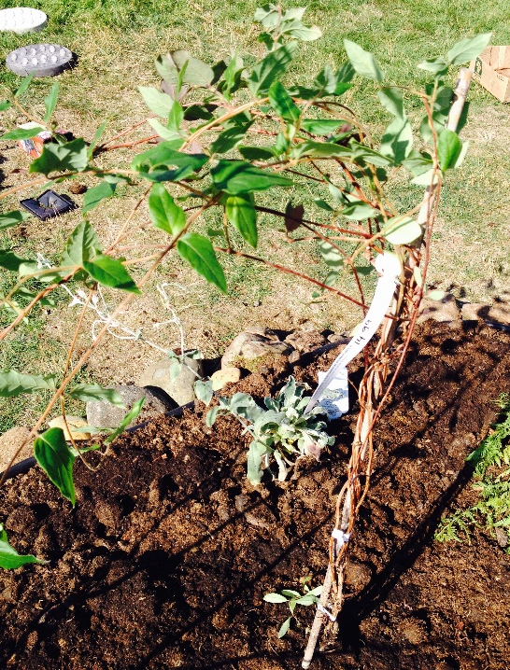
Aboriginal Name:
Scientific Name: Athyrium filix-femina
Common Name: lady fern
Description: A large, feathery species of fern that is said to be feminine because of its elegant and graceful appearance.
Image:
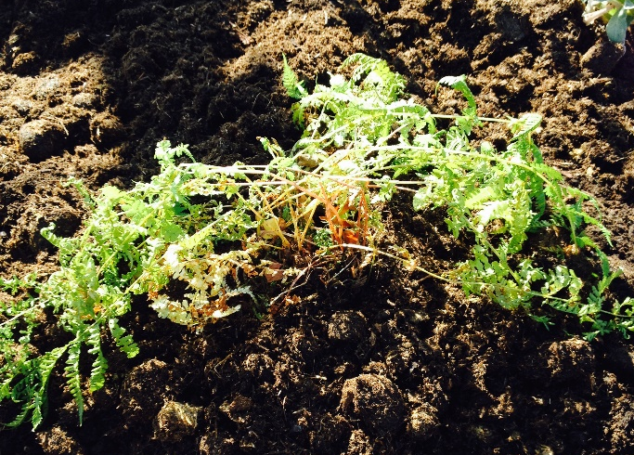
Aboriginal Name:
Scientific Name: Cornus racemosa
Common Names: Red-panicled Dogwood, Dogwood
Description: A multi-stemmed shrug that produces rounded clusters of creamy white flowers from March through June. It develops punches of white berries on it’s bright red stems. The leaves are narrow and turn a striking purple/red colour in the fall.
Image:

Aboriginal Name:
Scientific Name: Thuja plicata
Common Names: Western Red Cedar, Pacific redcedar, shinglewood
Description: This is an evergreen coniferous tree that is the provincial tree of British Columbia. t has extensive applications for Native Americans of the Pacific Northwest. The foliage forms flat sprays with scale-like leaves in opposite pairs. The foliage sprays are green above and green marked with whitish stomatal bands below.
Image:

Aboriginal Name:
Scientific Name: Polystichum munitum
Common Names: sword fern
Description: An evergreen fern native to western North America. The dark green fronds of this fern grow 50 to 180 centimetres tall, in a tight clump spreading out radially from a round base. They produce light yellow spores.
Image:
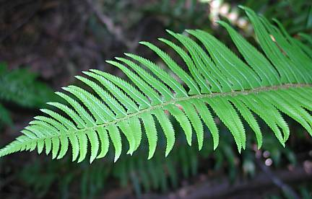
Possible teaching activities:
- Work with students to find out the aboriginal names of all the plants
- Work as a class to investigate the traditional uses of each of the plants (what parts were used and what for)

